Website Hacking

Revision

Day 1
Topic - VEGA VULNERABILITY SCANNER [link]
- Vega helps you find and fix cross-site scripting (XSS), SQL injection, and more.
- Vega is a free and open-source web security scanner and web security testing platform to test the security of web applications. Vega can help you find and validate SQL Injection, Cross-Site Scripting (XSS), inadvertently disclosed sensitive information, and other vulnerabilities. It is written in Java, GUI based, and runs on Linux, OS X, and Windows.
- Vega can help you find vulnerabilities such as: reflected cross-site scripting, stored cross-site scripting, blind SQL injection, remote file includes, shell injection, and others. Vega also probes for TLS / SSL security settings and identifies opportunities for improving the security of your TLS servers.
- Vega includes an automated scanner for quick tests and an intercepting proxy for tactical inspection. The Vega scanner finds XSS (cross-site scripting), SQL injection, and other vulnerabilities. Vega can be extended using a powerful API in the language of the web: JavaScript.
- Automated, Manual, and Hybrid Security Testing –
- Automated Scanner: Vega includes a website crawler powering its automated scanner. Vega can automatically log into websites when supplied with user credentials.
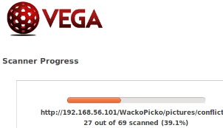
- Intercepting Proxy: Vega can be used to observe and interact with communication between clients and servers, and will perform SSL interception for HTTP websites.
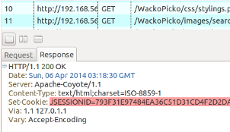
- Proxy Scanner: the Vega proxy can also be configured to run attack modules while the user is browsing the target site through it. This allows for semi-automated, user-driven security testing to ensure maximum code coverage.
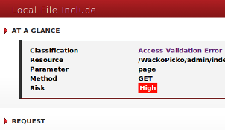

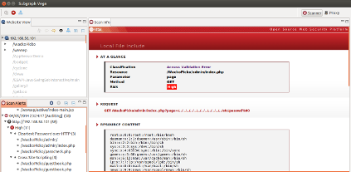
Features –
- GUI-Based
Vega has a well-designed graphical user-interface.

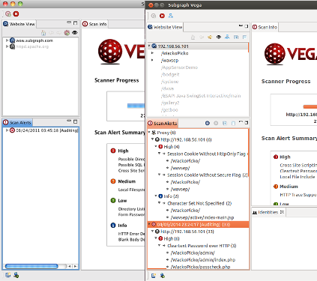
- Multi-Platform
Vega is written in Java and runs on Linux, OS X, and Windows.

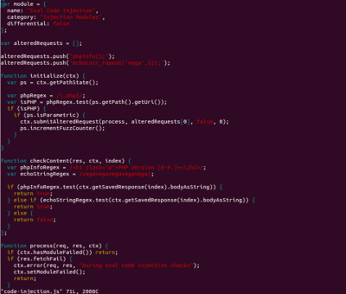
- Extensible
Vega detection modules are written in JavaScript. It is easy to create new attack modules using the rich API exposed by Vega.

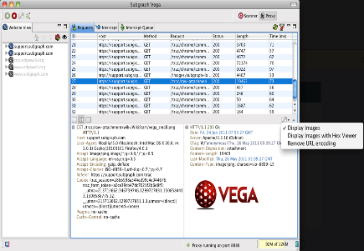
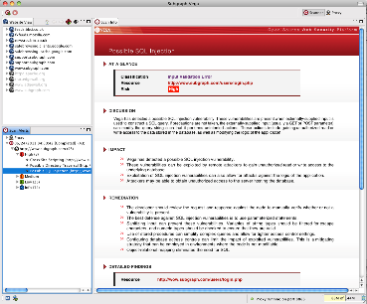
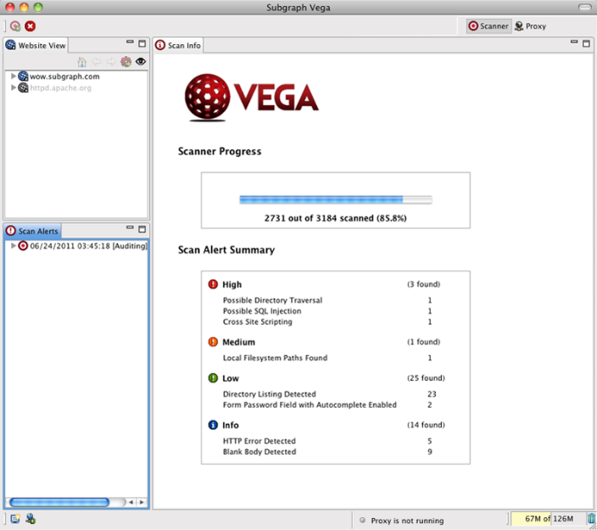
- Using Vega to perform an automated vulnerability scan against a web application.

